**A**

**PROJECT REPORT**

ON

+

**PMPML TICKECTGHAR**

Submitted in partial fulfillment for the award of

**Post Graduate Diploma in Advance Computing**

**(PG-DAC) from**

**INSTITUTE OF EMERGING TECHNOLOGIES**

**Authorized Training Centre**



**Under the Guidance of**

**Ms. Savita**

**BY**

**Mr. Anup Sanjiv Adhau 240345920013**

**Mr. Kanak Niraj Gupta 240345920034**

**Mr. Abhishek Pravin Malgaonkar 240345920042**

**Mr. Tejas Hemantrao Patil 240345920095**



**CERTIFICATE**

This is to certify that the project report entitled ( **PMPML TICKECTGHAR** ) is a bonfire work carried out by ( **Anup Sanjiv Adhau, Kanak Niraj Gupta, Abhishek Pravin Malgaonkar, Tejas Hemantrao Patil** ) andsubmitted in partial fulfilment ofthe requirement for the C-DAC ACTS, DAC course in Institute of Emerging Technology in the batch of Mar 2024.

**Course Coordinator** **External Examiner**

(Size 14 Times New Roman,bold )

**ACKNOWLEDGEMENT**

This project **PMPML TICKECTGHAR** was a great learning experience for us and we are submitting this work to Advanced Computing Training School (CDAC).

We are very glad to mention the **Ms. Savita** for her valuableguidance to work on this project. Her guidance and support helped us to overcome various obstacles and intricacies during the course of project work.

Our most heart full thanks goes to ***Mr. Sangram Patil*** **(Director ,IET)**who gave all the required support and kind coordination to provide all the necessities like required hardware , internet facility and extra lab hours to complete the project and throughout the course up to the last day here in C-DAC ACTS, Pune.

**Name of Students Roll no.** Sign of student

**Mr. Anup Sanjiv Adhau 13**

**Mr. Kanak Niraj Gupta 34**

**Mr. Abhishek Pravin Malgaonkar 42**

**Mr. Tejas Hemantrao Patil 95**

**Abstract**

The PMPML Ticketghar Project has been devised with the primary motive of streamlining as well as improving the booking of bus tickets for passengers, bus operators and admin. This project adopts new web technologies with a view of enabling passengers to search for bus routes & book tickets online.  
  
The system is designed to make a hassle free experience through such factors as safe payment methods, and auto generated booking confirmation through e-mail and text message. There is also an administrative module that can be used by operators for scheduling of tasks, making bookings alterations and also produces reports of the sales and vacancies of the house. The aim therefore will entail simplification of the existing complex bus booking systems, ease of access for the passengers, and efficiency of the bus companies.  
  
With this project, possible is to create a system capable to address the needs of users and operators on transport industry to enhance the connectedness and convenience of mobility.

**Index**

|  |  |  |
| --- | --- | --- |
| **Sr. No.** | **Title** | **Page No.** |
| **1** | Introduction |  |
| **2** | Problem Definition & Scope |  |
| **2.1** | Problem Definition |  |
| **2.2** | Goals & Objectives |  |
| **2.3** | Major Constraints& Outcomes |  |
| **3** | Software Requirement Specification |  |
| **3.1** | Purposed System |  |
| **3.2** | Scope |  |
| **4** | System Modules |  |
| **5** | Performance-Requirements |  |
| **5.1** | H/W Requirements & S/W Requirements |  |
| **6** | UML Diagram |  |
| **6.1** | DFD |  |
| **6.2** | ERD |  |
| **6.3** | Use case diagram |  |
| **6.4** | Class Diagram |  |
| **6.5** | Sequence diagram |  |
| **6.6** | Activity Diagram |  |
| **6.7** | Deployment diagram |  |
| **6.8** | System Architecture |  |
| **7** | Test Cases |  |
| **8** | Screenshots |  |
| **9** | References |  |

1. **INTRODUCTION**

The PMPML Ticketghar is a new model for booking and travel in buses that is causing a stir and has the potential to revolutionize the bus transport sector. This is particularly relevant today given that people are looking forward towards saving their time and efforts; the services that are being offered on this site can be gotten on the internet at any given date and time.

The traditional method of booking bus tickets involves standing in a queue for several hours or even days, limited number of seats to choose from and are extremely costly. In order to overcome these challenges, we provide timetables of buses and their service prices on our website. Customers can weigh the various buses available in the market, choose what they desire, and complete the bookings within the shortest time possible.

The structure of the site is built using modern Web technologies to ensure the reliability, speed, and safety of the platform. Bus Booking Website will contain facilities like Secure payment techniques, Instant confirmation facility and customer Care to minimize the factors like insecurity, delays and the uncertainties that are often attached to bus travel. As for the Bus Booking Website, all travelling aspects, as well as the link between passengers and bus operators, are discussed with the main aim of creating a convenient, efficient and effective means of transport.

1. **Problem Definition & Scope**

The Bus Booking Project is designed to offer a scalable, efficient, and user-friendly solution to the challenges faced by passengers and bus operators in the traditional booking process. By leveraging modern technologies, the project aims to transform bus travel into a more transparent, convenient, and enjoyable experience for all stakeholders.

* 1. **Problem Definition**

This is the generally acknowledged conventional ways of booking bus tickets where inefficiencies and inconveniences are common to frequent travellers and bus operators. undefined  
**Lack of Transparency:** On Flexible Accommodation changes, customer inconvenience arises from the inability to data acquire real-time of seats, schedules, and price of the flight.  
**Inconvenient Booking Methods:** Dependence on the counter tickets or ticketing agencies, which entails time consuming, restricted operations, and charges on top of the ticket price.  
**Limited Access to Information:** Lack of awareness of the specific operators/providing services, and hence their inability to make more informed decisions in the selection of the providers.  
**Payment Issues:** Few modes of payment available and issues concerning the safety of transactions to discourage individuals from using online reservation systems.  
**Operational Inefficiencies for Bus Operators:** Manual booking techniques, scheduling, and inefficient use of available resources may pose serious challenges to the profits and customer satisfaction.

* 1. **Goals & Objectives**

**Goals**:-

The primary objective of developing the PMPML TICKECTGHAR Project is to improve the Ticketing System to make it easy for passengers and bus operators to operate the project for the sale of tickets and other services. It is committed to improving the quality and efficiency of travel through accurate information, safety, and effective control of reservations.

**Objectives:-**

1. Enhance User Experience:

Design an interface simple and usable where the passengers can easily search for the bus routes, fares, seats and complete their bookings without much upon.

Update seats that are available and when the buses are to arrive and how much it will cost the users to have that information while using the App so that they get the most accurate information.

2. Improve Accessibility:

Develop a ticket booking website that will be compatible with browser on both the PC and smartphones so that individuals can book tickets at their own convenience.

Ensure that many types of languages and methods of payment are accepted to cater for the many users.

Increase Operational Efficiency for Bus Operators:Increase Operational Efficiency for Bus

3. Operators:

Feature a solid back-end mechanism whereby bus operators can monitor and support operational fleets, timetables, and costs structures.

Simplify the booking and seat provision systems so that there is less chance of mistakes and over booking.

4. Ensure Data Security and Compliance:Ensure Data Security and Compliance:

Implement payment gateways to safeguard the consumer’s payments and other sensitive data.

Comply with relevant data protection legislation (s, particularly those of the European Union that recognizes protection of individuals’ data by compliance with General Data Protection Regulations or GDPR. Provide Comprehensive Reporting and Analytics:Provide Comprehensive Reporting

5. Analytics:

Produce materials such as records of daily sales, number of passengers to do an assessment of the amount of occupancy on daily, weekly, or monthly basis and feedback forms for the passengers to fill and give their opinions on how services can be improved.

Provide information on user needs and preferences that will enable the operators to devise ways of improving on their services.

6. Facilitate Seamless Communication:

Setup a notification process that sends notifications to passengers on bookings, bookings confirmation, schedule changes and other vital information using emails and or text messages.

It was recommended that the platform should develop a help desk – frequently asked questions and chat – in case users face difficulties.

7. Promote Sustainability:

Encourage the adoption of paperless tickets so as to reduce the use of paper tickets during events. Thus, the following recommendations can be put into place to promote the use of public transport through bus travel

8. Scalability and Future Expansion:

Make the platform capable to receive, process and accommodate large amount of Internet traffic and orders, with further increase in numbers of users and bus operators.

Look into the possibilities of adding more services that can be integrated with the app like loyalty program, choices of ride hailing services and others related to travel.

* 1. **Major Constraints& Outcomes**

**Major Constraints:-**

1. Technical Limitations:

Integration Challenges: Here, one may experience some issues while integrating with different operators’ systems because of the difference in the used technology, data structures, and security frameworks.

Scalability: Before choosing a particular concept they have to be sure that it would work fine if tens, hundreds of people try to use it during the peak traveling periods.

Security Requirements: For the protection of the sensitive equipment data that is often hard and expensive to achieve technically use stringent approaches.

2. Regulatory and Compliance Constraints:

Data Protection Laws: Adherence to rules, for instance, GDPR and other standards of data protection of the users’ place of residence.

Transportation Regulations: Following the rules of the transportation sector that may have certain guidelines in regard to a certain country or state a services.

3. Financial Constraints:

Budget Limitations: A small amount of money is available to invest on the project, the list of goals defined and the number of technologies to be implemented on the project, the advertisement of the processes and the professionals to be hired can be constrained.

Revenue Generation: The capacity to ensure that it will be able to generate enough revenues in its booking fees, partnership, or advertisements to defray expenses and finance growth.

4. User Adoption and Behavior:

User Resistance: Users accustomed to the other forms of booking which will make them sparing with the new platform and hence slow.

Training and Support: Some layout decisions may cause confusion to the passengers and bus operators, meaning that a platform will have to be designed in such a way that most of the passangers and bus operators are able to understand which may in turn take up much time in training and support.

5. Operational Challenges:

Maintaining Real-Time Data: This include schedules, seating availability and other data may have to be updated across operating multiple operators and locations and this tends to be cumbersome and can lead to making wrong decisions.

Customer Support: By and large, the leading customer care whenever there is an issue with booking, a customer needs to request a refund, or whenever a schedule changed is extremely cumbersome and is very likely to consume a lot of resources.

**Expected Outcomes :-**

1. Enhanced User Experience:

This means that passengers will experience an easy time when making bookings since they will be in a position to search for the buses, pick their favorite seats, and even make payment online.

More sales and customer satisfaction through provision of timely update on inventory, displaying cost prices, and other special notifications.

2. Increased Operational Efficiency for Bus Operators:

Bus operators shall be able to manage the schedules, the fleets and the bookings in a better way which would result into reduction of some of the errors that are experienced currently.

Higher decision making with the help of detailed analysis and reporting of different aspects that help in better pricing and improved services.

3. Wider Accessibility and Reach:

It will be available for use by any person, from any internet-enabled device, or from any part of the world which will expand the market for the platform.

Availability of multiple payment options and language options would help the organization to expand the base of its users.

4. Improved Revenue Streams:

It will create the base of new revenues from the fees for reservations, service of travel services, and advertising.

Bus operators will be in a position to make a modification on the use of dynamic pricing, thus propelling profits during peak and off-peak periods.

5. Secure and Compliant Operations:

It shall strictly maintain the security of the users’ data, and shall also follow the laws governing such aspects to give users confidence in the platform.

Harmonisation of particularities concerned with legal frameworks will reduce a possibility to face legal consequences adversely affecting the company’s activities across multiple regions.

6. Environmental and Social Impact:

That way, through increased ticket digitalization and fewer printed tickets, the platform will be eco-friendly.

Ease of access to buses and convenience of the service will result in more people using the service thus reducing on congestion on the roads and emissions to the atmosphere.

7. Scalability and Future Growth:

The platform will be built with extensibility in mind and new features, linking to other travel related services, geographical markets can be easily added.

Acknowledging user feedback and changing technologies will also be used to always make incremental adaptations that will enable the platform to stay relevant in the long run.

**3. Software Requirement Specification (SRS)**

**1. Introduction**

1.1 Purpose

This document is to define the software requirements of the Bus Booking Project with respect to the functionalities, constraints and design issues of the suggested system.

1.2 Document Conventions

This document follows conventional standards for software documentation. Its format is designed for easy comprehension and implementation.

1.3 Intended Audience and Reading Suggestions

The intended audience includes the following: software developers, system architects, project managers, stakeholders, quality assurance teams. Each of these roles is expected to partially read this document.

1.4 Product Scope

PMPML Ticketghar Project work involves developing an e-ticketing platform for passengers. This system provides an online bus schedule to the passenger to enable them to book tickets and make payments online. During this process, it helps the bus operators to efficiently manage their fleet, schedules, and bookings.

1.5 References

It provides references to industry standards, specifications of the technology stack used, and all related documents that were in use at the time of system development.

**3.1 Proposed System**

The proposed PMPML Ticketghar System would be an integrated, user-friendly online platform that would address the inefficiencies of the traditional bus booking approach. It would have the following key features and functionalities:

**A**. **Key Features**

1.User Registration and Login:

Secure user registration and authentication with options for social media log-in.

User profile management, containing personal details, booking history, and preferences.

2. Bus Search and Selection:

A search engine that assists users in searching for buses by origin, destination, date, and time.

Filter options to further narrow down the search results based on price, operator, and bus type.

3. Real-Time Availability of Seat:

Real-time seat availability of selected buses to be displayed.

Interactive seat selection feature for users to select preferred seats.

4. Online Booking and Payment:

Secure booking with very many payment options, viz. credit/debit cards, digital wallets, and net banking.Integration with payment gateways to ensure secure and reliable transactions.

5. Booking Confirmation and Notifications:

Automatic booking confirmation sent via email and SMS.

Notifications on booking update, cancellation, and change of schedule.

6. Bus Operator Dashboard:

A full-featured dashboard for bus operators to manage schedules, routes, and pricing.

Tools to track seat occupancy, manage bookings, and generate reports.

7. Administrative Tools

Role-based access control to manage users, operators, and content.

System settings and configurations, including setting up payment gateways, notification settings, and data management.

8. Reporting and Analytics:

In-depth reporting on bookings, sales, and any other customer behavior.

Analytics tools for trend understanding, route optimization, and service improvement.

**B. System Architecture**

Modular Design: It will provide a modular system architecture that would enable the easy maintenance of the system and allow for future enhancements.

API Integration: The system is integrated with third-party services through APIs for payment processing, notification, and mapping.

Database Management: A robust database system to house user data, booking details, schedules, and other critical pieces of information.

Security Measures: Implementing SSL encryption, authentication, and other security measures for the protection of user information.

**3.2 Scope**

**A.** **Functional Scope:**

The Bus Booking System will be applied in the following functional areas:

1. Passenger Experience:

Search for and book bus tickets with a user-friendly interface.

Safe payment processing and booking management.

View booking history and edit account settings.

2. Bus Operator Management:

Manage bus fleets, schedules, and pricing.

Monitor the progress of bookings and seat availability in real-time.

Reporting tools on finance and operation insights.

3. Administrative Control:

User, operator, and system setting management.

Manage Website Content, FAQs, help sections andOperator Details

System Performance monitoring and management along with the security.

**B.** **Non-Functional Scope:**

1. Performance:

The system will be optimized for fast loading times and smooth performance even in high traffic conditions

2. Scalability:

Designed to scale with increasing users and added functionality while maintaining consistent performance

3. Reliability:

High availability and reliability with minimal downtown and comprehensive backup systems

4. Security:

Security best practices implemented within the ecology, including data encryption, secure payment gateways, and regular safety audits. Usability: User experience driven by intuitive navigation, clear instructions, and responsive design for both mobile and desktop users.

5. Compliance:

Full compliance with data protection regulations and the standards for the transportation industry to ensure an enterprise operates within the boundaries of the law and ethics.

**4. System Modules**

**5. Performance-Requirements**

**5.1 H/W Requirements & S/W Requirements**

**1. Hardware Requirements (H/W)**

Hardware requirements are depending on the scope of work in the PMPML Ticketghar Project, how many numbers of users are covered, and what is the expected traffic. Some of the general hardware requirements are given as below:

**A.** **Server-Side Hardware Requirements**

1. Server/ Number of Servers

* Processor: Multi-core (at least 8 Cores); recommended (Intel Xeon/AMD EPYC).
* RAM: Minimum 16 GB; recommended 32 GB or above for the best performance and to handle high traffic.
* Storage:

At least a 500 GB SSD would be good to make the data retrieval faster. Extra HDDs for backup and archival (the capacity depends on the data retention guidelines).

* Interface to the Network: It should have an Ethernet card of 1 Gbps at least that would ensure faster and reliable communication to the network.
* Redundancy: It should be RAID with storage redundancy, and failover solutions like load balancers for high-availability solutions.

2. Database Servers

* Processor: Multi-core processor, similar to the application server.
* RAM: At least 32 GB but ideally 64 GB or more, depending on the size and load of the database.
* Storage: SSDs of high speed with enough space, depending on the expected volume of data.
* Backup Solution: Backup systems should be automated with off-site storage.

**B. Client-Side Hardware Requirements**

1. User Devices:

* Desktop/Laptop:
* Processor: Dual-core processor (e.g., Intel Core i3 or AMD Ryzen 3).
* RAM: Minimum 4 GB.
* Storage: Free space of 50 GB.
* Display: 1280x720 px, minimum.
* Internet Connection: At least 2 Mbps stable broadband.
* Mobile Devices:
* Processor: Quad-core processor or higher, for instance Snapdragon, MediaTek.
* RAM: Minimum of 2 GB.
* Storage: 100 MB free space for the application.
* Internet Connection: A minimum of 3G/4G for seamless access.

**C. Network Infrastructure**

* Network Bandwidth: Sufficient bandwidth to let numerous users continue at the same time; the traffic is quite irregular and requires peaks, usually ranging at 100 Mbps or greater for internal communications within data centers.
* Firewalls and Security Appliances: Stateful firewalls along with intrusion detection systems and other cyber-threat security devices.
* Load Balancer: The function of spreading incoming web or application traffic among multiple servers to guarantee high availability.

**2. Software Requirements(S/W)**

The software requirements will, therefore, span from the Operating System, Application Software, and Database Management Systems to other development tools, testing, deployment, and maintenance.

**2.1 Server Side Software Requirement**

* Operating System:
* Web Server:

Linux-based (e.g., Ubuntu Server, CentOS, Red Hat Enterprise Linux) or Windows Server

To support necessary web server software, either Apache, Nginx, or IIS.

* Database Server:

Depending on the chosen DBMS, it would be either Linux-based or Window Server OS.

* Web Server Software:
* Apache or Nginx: to serve the web application
* SSL/TLS: to secure communications across the network
* Database Management System (DBMS):
* MySQL/MariaDB, Microsoft SQL Server — for management of the relational database.
* Backup Tools: require mysqldump, pg_dump tools, or third-party solutions with an automated backup
* Programming Languages and Frameworks:
* Backend: JavaScript (Node.js), ASP Dot Net, MVC Dot Net.
* Frontend: HTML/CSS/JavaScript using React.js
* APIs: RESTful API or GraphQL to make communication between the frontend and the backend.
* Other Server Software:
* Version Control System: Git (GitHub, GitLab).
* Containerization: Docker and Kubernetes for deployment and scaling.
* Monitoring Tools: Nagios, Prometheus, or Grafana for system monitoring and alerting.

**2.2 Client-Side Software Requirements**

* Web Browser: Google Chrome, Mozilla Firefox, Microsoft Edge, or Safari (latest versions) with the capability of running modern web standards—HTML5, CSS3, JavaScript ES6.
* Other Tools:
* PDF Reader: The application must allow viewing tickets and receipts.
* Email Client: The system functions should include receiving notification emails after a purchase.

**2.3 Development and Testing Tools**

* IDE/Code Editor: Visual Studio Code.
* Database Management Tools: Use phpMyAdmin, pgAdmin, or DBeaver to manage and manipulate databases.
* Testing Tools: Selenium, JUnit, and Postman to test APIs Jest, Mocha for JavaScript Testing
* CI/CD Tools: Jenkins, Travis CI.

**6. Unified Modeling Language (UML) Diagram**

Unified Modeling Language (UML) is a general-purpose modeling language. The main aim of UML is to define a standard way to visualize the way a system has been designed. It is quite similar to blueprints used in other fields of engineering. UML is not a programming language , it is rather a visual language.Understanding and effectively using UML can significantly improve the quality and clarity of your software designs. Our specialized course on System design provides detailed guidance and practical examples to help you master this visual language. By integrating UML into your workflow, you can create more comprehensive and communicative system models.

**6.1 Data Flow Diagram (DFD)**

**6.2 Entity-Relationship Diagram (ERD)**

**6.3 Use case Diagram**

**6.4 Class Diagram**

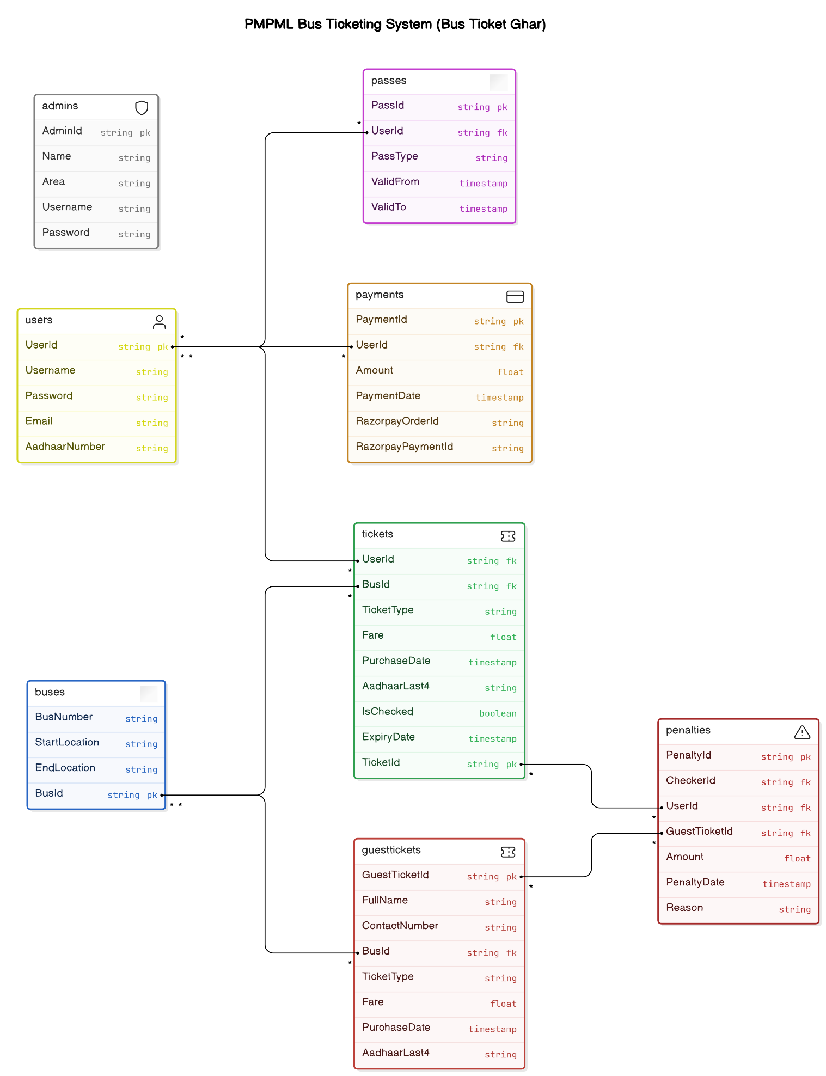

**6.5 Sequence Diagram**

**6.6 Activity Diagram**

**6.7 Deployment diagram**

**6.8 System Architecture**

**7. Test Cases**

**8. Screenshots**

**9. References**